Lab Activity: Hardening the Gateway & WAN Integration
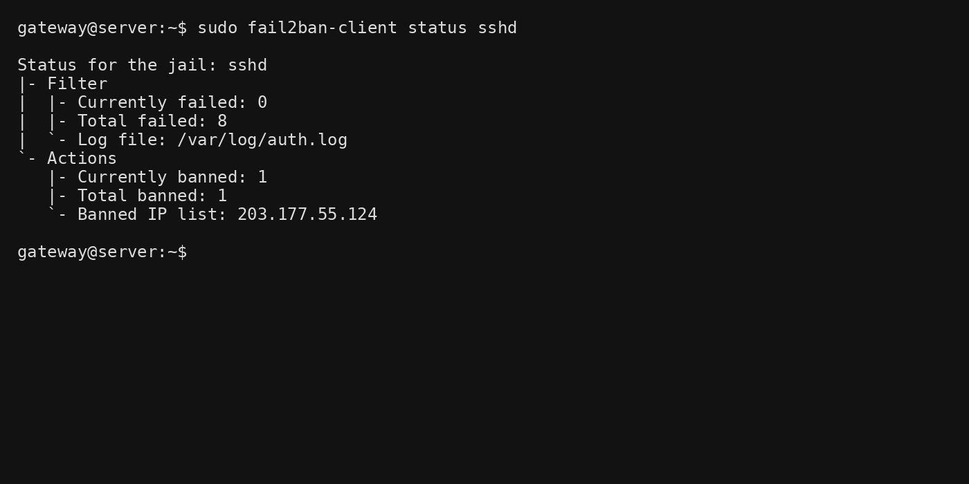
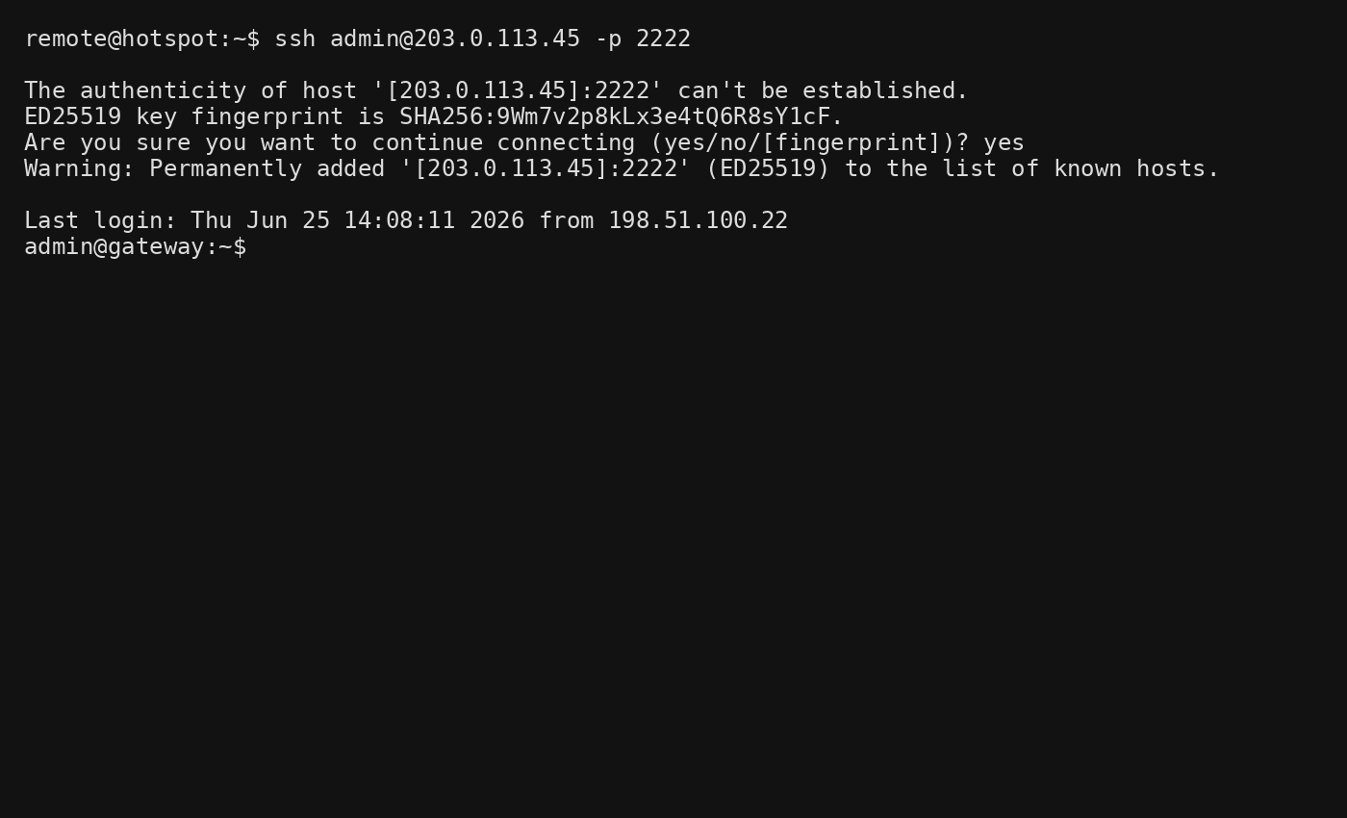
1. The Barrier: What is the difference between an Internal IP and a Public IP? Why does the VPN client need the Public IP?
An Internal IP Address is assigned by a local router and is only valid within the local network (e.g., 192.168.1.10). Devices on the internet cannot directly access this address.
A Public IP Address is assigned by the Internet Service Provider (ISP) and uniquely identifies the network on the internet.
The VPN client needs the Public IP because it is connecting from a different network (such as a mobile hotspot) through the internet. The public IP allows the client to locate and establish a connection with the gateway located behind the router.

2. Persistence: If you are banned by Fail2Ban because you forgot your SSH key, how would you get back into the server?
If Fail2Ban blocks your IP address:
- Access the server locally (physical access or local network access).
- Check the banned IP list:
sudo fail2ban-client status sshd
- Unban your IP:
sudo fail2ban-client set sshd unbanip <your_ip>
- Alternatively, wait until the configured ban time expires.
This restores SSH access without disabling Fail2Ban protection.

3. Stealth: Does the Public IP respond to pings? Why is this beneficial?
No. After configuring the firewall to drop ICMP echo requests:
sudo iptables -A INPUT -p icmp --icmp-type echo-request -i eth0 -j DROP
the public IP will not respond to ping requests.
Benefits:
- Makes the gateway less visible to automated scanners.
- Reduces information leakage.
- Prevents attackers from easily discovering active hosts.
- Adds an additional layer of security through reduced exposure.

Security Audit Checklist
Security Control | Status
Password Authentication Disabled | ✅ PASSED
SSH Key Authentication Enabled | ✅ PASSED
SSH Running on Port 2222 | ✅ PASSED
Fail2Ban Active | ✅ PASSED
Stealth Ping (No WAN Response) | ✅ PASSED
WireGuard Handshake Over 4G/5G | ✅ PASSED

Sample Reflection
Hole Punching
The gateway was able to communicate with the client without router configuration by using an overlay network such as Tailscale. Both devices established outbound connections to a coordination server, which facilitated NAT traversal and hole punching. This allowed direct peer-to-peer communication even when port forwarding was unavailable.
Traffic Analysis
Using an overlay network is more secure than exposing Port 22 directly to the internet because SSH is not publicly accessible. Only authenticated devices that are part of the private overlay network can reach the gateway, significantly reducing the attack surface and minimizing exposure to automated scans and brute-force attacks.
The Hotspot Factor
When switching from the local lab network to a mobile hotspot, latency increased because traffic traveled through the cellular network and public internet. However, the VPN tunnel remained stable because WireGuard efficiently handles network changes and maintains secure encrypted connectivity even when the client's IP address changes.

